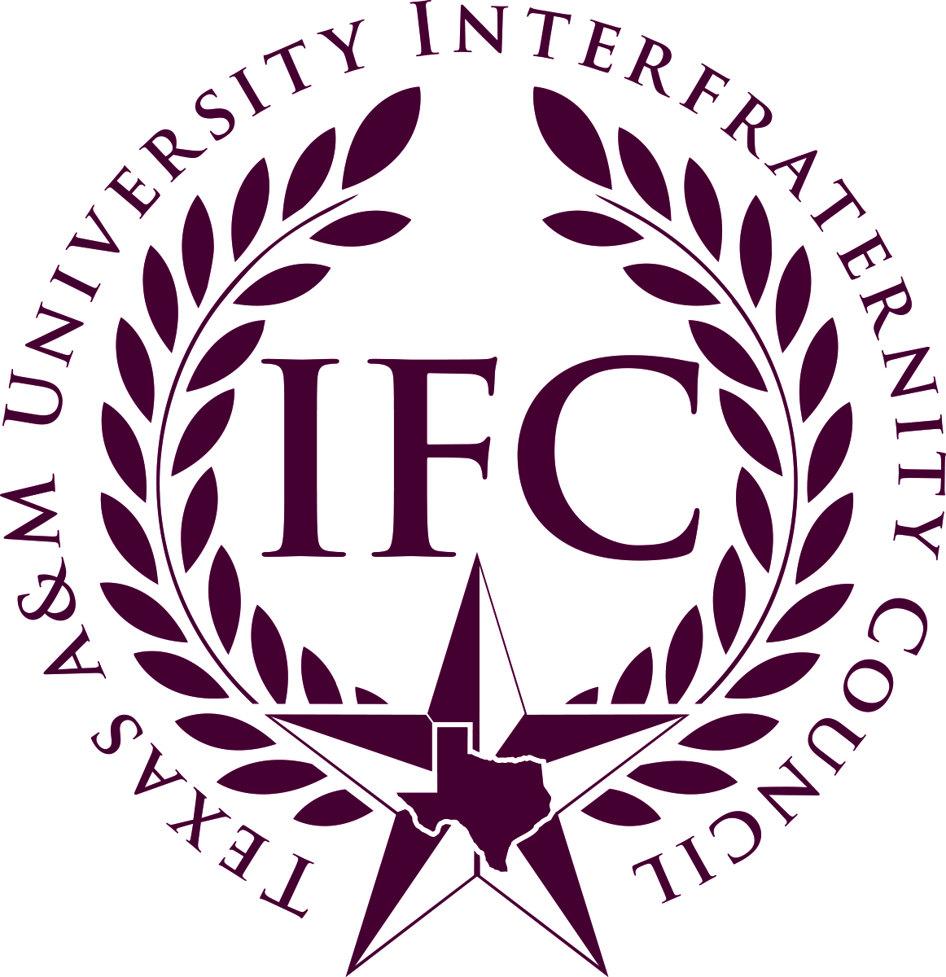

POLICY PROHIBITING ALCOHOL ABOVE 15% ABV

Context: Recently several national and executive chapters, along with the NIC have passed legislation prohibiting the presence of hard liquor at chapter events unless a third party vendor is present. This resolution is in response to the concern for the health and safety of chapter members at Texas A&M. Having hard liquor at events presents an added risk for those attending and unnecessary liability for chapter executives.

Resolution: Each Interfraternity Council member fraternity will adopt and implement a policy by January 15th, 2019, that prohibits the presence of alcohol products above 15% ABV at any chapter event, except when served by a licensed third-party vendor and is a cash bar. In addition, beverages made with Alcohol with a 15% ABV may not be present during chapter events (ex: Trash Can Punch).
All chapters must provide written proof that this has amendment has been put in place by January 15th, 2019 through the submission of revised chapter bylaws updates or meeting minutes. This should be submitted to the IFC Parliamentarian no later than January 18, 2019.
TEXAS A&M IFC JUDICIAL CODE – ARTICLE XII, Section 2(A.2)
2. No alcohol products above 15% ABV shall be present in any chapter facility or at any chapter event, except when served by a licensed third-party vendor.

